MATHS - 2003 (Set III— Outside Delhi)
Except for the following questions, all the remaining questions have been asked in Set I & Set II.
Q.1. Solve
Ans. 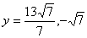
Or
Solve the equation: 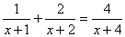
Ans.
Q. 2. Find the GCD and LCM of the following polynomials:
Or
If the GCD of and is find the values of
Ans. (a = -2); (b = -1)
Q. 3. Find the value of for which the following system of linear equations has infinite number of solutions: Ans.
Q. 4. Express the following as a rational expression in lowest form:
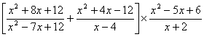
Ans. (1)
Q. 15. The adjoining pie chart shows the number of students of a school using different modes of travel to School.
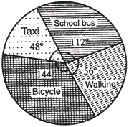
If 360 students come to the school on bicycle, answer the questions given below.
(i) How many students are there in the school?
(ii) How many students come to the school by school bus?
(iii) How many students travel by taxi to reach the school?
(iv) What is the ratio of students coming by school bus to those who come on foot? Ans. (i) 900; (ii) 280; (iii) 120; (iv) 2 : 1
Q. 16. A teacher on attempting to arrange the students for mass drill in the form of a solid square found that 24 students were left. When he increased the size of the square by one student, he found that he was short of 25 students. Find the number of students.
Ans. (600)
Or
Out of a number of Saras birds, one-fourth of the number are moving about in lots, 1/9th coupled with 1/4th as well as 7 times the square-root of the number move on a hill, 56 birds remain in the vakula trees. What is the total number of birds?
Ans. (576)
Q. 19. Without using trigonometric tables, evaluate the following:
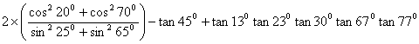
Ans. 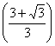
Q. 20. A T.V. is sold for Rs. 30,000 cash or Rs. 17,500 as cash down payment and instalments of Rs. 1,600 per month for eight months. Determine the rate of interest correct to one decimal place under instalment plan. Ans.(6.5%)
Q. 21. The hypotenuse of a right triangle is cm. If the smaller side is tripled and longer side is doubled, the new hypotenuse will be 15 cm. Find the length of each side.
Ans. (3 cm and 6 cm)

